|  |
| --- |
| **A mini-project report on**  **Ticket Booking ChatBot**  *submitted in partial fulfillment of the*  *requirements for*  **BE (Information Technology)**  *by*  **KAZI JAWWAD A RAHIM (Reg. no T-16-0020)**  **KIRATKAR GUNJAN NARAYAN (Reg. no T-16-0080)**  **GHADAGE SAHIL SHRIRANG (Reg. no T-15-0181)**  **…………………**  *under the guidance of*  **Prof. Omkar D. Dike**  main_logo  Department of Information Technology  Finolex Academy of Management and Technology, Ratnagiri  October 2019 |

**Abstract**

There are many websites which provides online ticket booking services. One of the best examples of such websites are PayTM, BookMyTicket, etc. But such websites do not provide bot services users. Hence, our main aim is to develop an online ticket booking chatbot system for us which will be useful by user to book tickets. This is a mini-project, therefore it may lack some more services, but extension of this will surely give better results. The project is implemented in Python using NLTK library class. In this chatbot we have implemented some features which will be useful for ticket booking. Here user will be allowed to choose source and destination and based on that available trains will be displayed. User will then choose the train and the available classes. On the basis of that user will choose the seating structure and then the final payment will be shown to user. After successful payment booking id will be displayed to user.

**SOFTWARE REUIREMENTS:**

**1) Python**

**2) NLTK Library**

**SOURCE CODE:**

from nltk.chat.util import Chat,reflections

import random

pairs = [

[r"hi|hey|hello",["Hey there. Welcome to Online Ticket Booking ChatBot.\nEnter Source Location:(Begin with Source: )"]],

[r"Source:(.\*)",["Enter Destination Location:(Begin with Destination: )"]],

[r"Destination:(.\*)",["Tutari Express,KokanKanya Express, Matsyaganda Express, Rajdhani Express"]],

[r"Tutari Express|KokanKanya Express|Matsyaganda Express|Rajdhani Express",["Sleeper Class, 2S, AC1, AC2"]],

[r"Sleeper Class",["Rs. 244","Rs. 250","Rs. 260"]],

[r"2S",["Rs. 180","Rs. 185","Rs. 190"]],

[r"AC1",["Rs. 1500","Rs. 1600","Rs. 2000"]],

[r"AC2",["Rs.900","Rs. 1200","Rs. 1500"]],

[r"Payment done|payment done",["Thank You for the payment\nYour Booking number is BKID0000"+str(random.randrange(0,2000))]],

[r"quit",["Bye take care. See you soon :) ","It was nice talking to you. See you soon :)"]]

]

def chatty():

print("Hi, I'm JoJo and I chat alot :)\nPlease type lowercase English language to start a conversation. Type 'quit' to leave ") #default message at the start

chat = Chat(pairs, reflections)

chat.converse()

if \_\_name\_\_ == "\_\_main\_\_":

chatty()

**OUTPUT:**

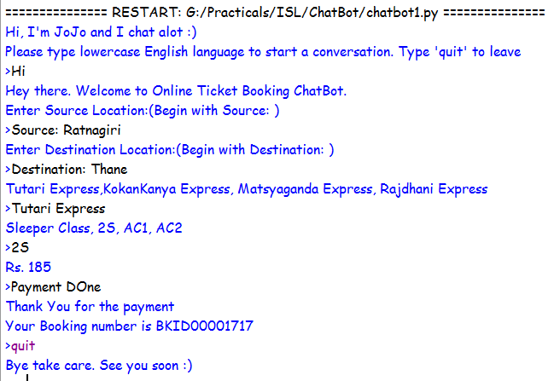

**CONCLUSION:**

In this project we have developed a chat bot which will be useful in train ticket booking. This Bot was intentionally made for the purpose of easing the ticket booking service. This optimize the headache of ticket booking by various vendors. It also minimizes the time required for ticket booking.